START UP- LEGAL AND ETHICAL STEPS
16TH MARCH 2026 (MONDAY)

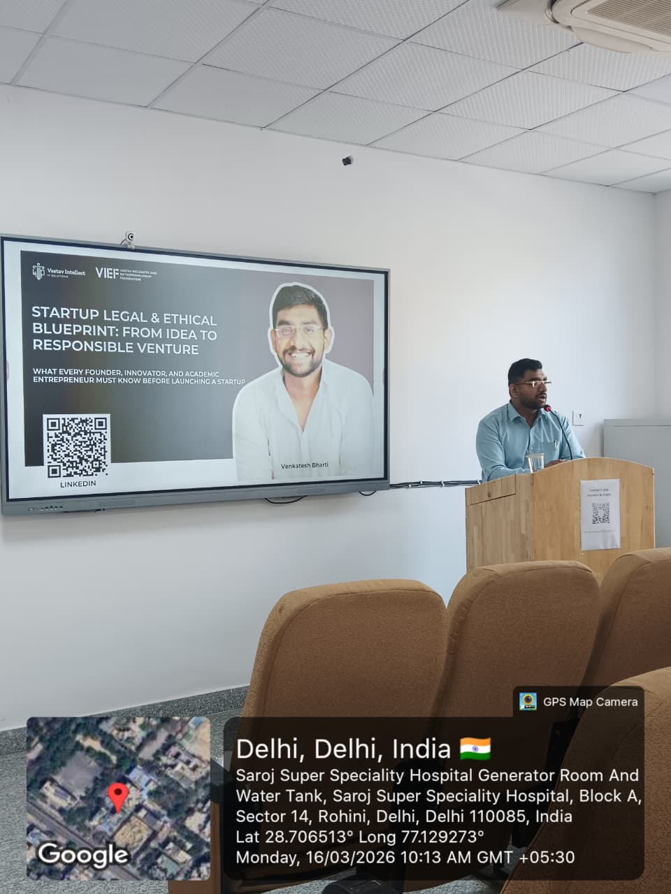 | 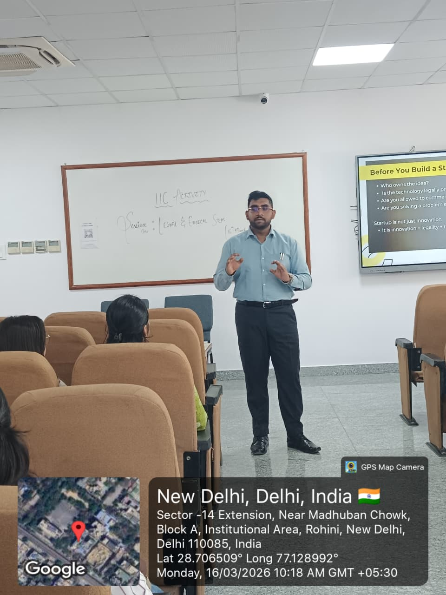
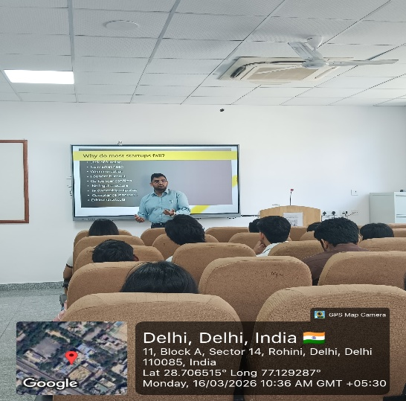 | 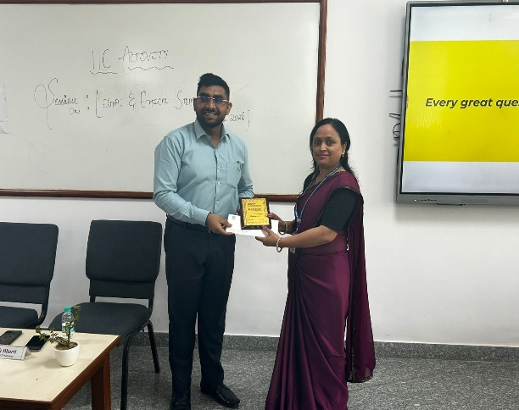

The Session on ‘Start-up Legal & Ethical Steps’ was successfully organized as a one-day IIC activity on March 16, 2026, aimed at bridging the gap between innovative disruption and foundational stability. In the contemporary entrepreneurial ecosystem, start-ups are often driven by the urgent need to scale and innovate, sometimes perceiving legal frameworks and ethical considerations as secondary concerns or "speed bumps". This session was specifically designed to highlight critical legal milestones, including intellectual property protection, regulatory compliance, and corporate governance, while emphasizing the importance of adopting ethical practices to build stakeholder trust. By addressing these complexities early, the program sought to help aspiring entrepreneurs and student innovators transform potential liabilities into a formidable competitive advantage.
Mr. Venkatesh Bharti, a distinguished scientist, inventor, and founder associated with Vastav Intellect IP Solutions, VIEF, and several other ventures such as Assesme AI and Neuroventa, served as the resource person. His extensive experience as a startup mentor and consultant provided students with practical insights into the innovation and startup ecosystem. The interactive expert talk allowed students to engage directly with a founder who has successfully navigated the complexities of entity registration and intellectual property rights.
The event addressed a critical need identification, as many early-stage founders possess strong technical ideas but lack adequate awareness of the legal obligations associated with operating a start-up. This knowledge gap often leads to challenges regarding contractual arrangements and ethical decision-making, which can undermine the sustainability of entrepreneurial initiatives. The modern landscape is increasingly filled with "zombie startups"—ventures that may have had brilliant products but crumbled under preventable legal disputes. To combat this, the session provided a structured roadmap for participants to identify and secure intellectual property and formalize founder relationships before they become liabilities. The program served to move participants from a state of unconscious incompetence regarding regulatory compliance toward a more structured and legally compliant approach.The session also showcased innovative projects developed by students, fostering a collaborative environment where young innovators could gain feedback on their models. This interaction was vital for helping participants understand the essential steps required both before and after start-up registration.
The program successfully equipped the target audience, which included students from BBA sections M2A and M2B, with a prioritized legal roadmap. Participants developed a foundational understanding of the legal framework governing start-ups, particularly regarding entity formation and the mitigation of regulatory risks. Beyond the technicalities of the law, the session achieved its objective of helping students implement an ethical decision-making framework that aligns daily operations with long-term consumer trust. By the end of the day, attendees were better prepared to identify specific regulatory red flags within their own business models and understand the appropriate measures to mitigate such risks before attempting to scale their ventures.
The event concluded with an assessment in the form of a quiz to ensure that the core objectives of the session were met. Under the monitoring and reporting of Dr. Seema Modi and Ms. Prachi Sharma, the session reinforced the institution's commitment to promoting responsible and transparent business practices among its students. Overall, the event proved to be highly informative and impactful, enhancing awareness and fostering an IP-conscious academic and professional environment within the institution.

FLYER OF THE EVENT
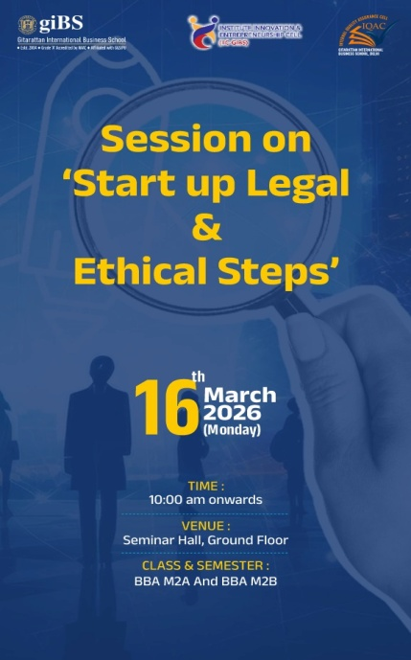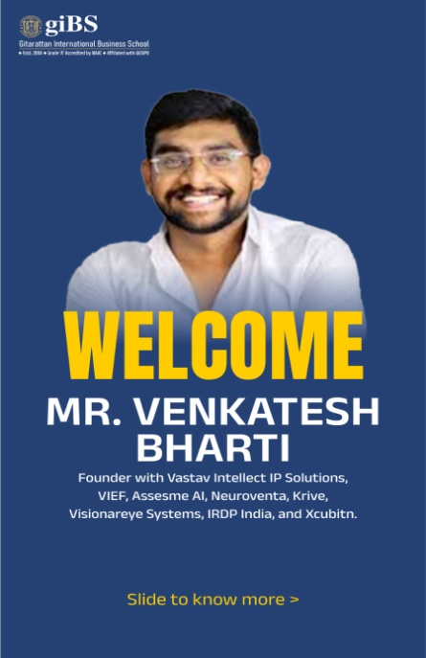
TYPE OF EVENT | IIC Event
VENUE | Seminar Hall, Ground Floor, GIBS
TIME & DURATION | 10:00 AM onwards
CONDUCTED BY | CLS-GIBS
ORGANISED FOR | BBA M2A and BBA M2B
NAME OF THE COORDINATOR | Dr. Seema Modi and Ms. Prachi Sharma
ATTENDANCE | 99
RESOURCEPERSON | Mr. Venkatesh Bharti
OBJECTIVES OF THE EVENT | - To equip founders with a chronological roadmap of mandatory compliance to identify and secure intellectual property and formalize founder relationships before they become liabilities.  - To provide a framework for embedding ethical decision-making into a company’s DNA to ensure that principled governance enhances brand valuation and attracts high-quality institutional investment.
LEARNING OUTCOME | - Participants possessed a prioritized legal roadmap to navigate entity registration, intellectual property protection, and founder equity without costly errors.  - Founders were able to implement an ethical decision-making framework that aligns daily operations with long-term investor and consumer trust.  - Attendees were able to identify specific regulatory red flags within their current business models and gain the tools to mitigate those risks before scaling.
SHORTFALL DURING EVENT | N/A
LINK OF ONLINE VIDEO | https://youtu.be/dZV7fVOAhns

PREPARED & SUBMITTED BY: DR. SEEMA MODI AND MS. PRACHI SHARMA, ASSISTANT PROFESSORS, CLS, GIBS

