MY STORY: MOTIVATIONAL SESSION BY SUCCESSFULL ENTREPRENEUR/ STARTUP FOUNDER
On
5th November, 2022

GIBS organized a Webinar on 05th November 2022 on the topic My Story: Motivational session by a successful Entrepreneur/ startup founder. Ms. Sonal Agarwal Bali, Founder, Diligent Consulting & Deputy CFO-Intello Labs was the speaker for the session. She is the CA with 20 years of experience in controlling the finances function and managing cross functional relationship.
The event was organized for BBA LLB, BA LLB, BBA 1st and 2nd Shift, MBA, and MBA IB. The Program focused to provide opportunities to Undergraduate students, Postgraduate students and Faculty members to expand their dexterities in various significant facets involved in building Career Opportunities in Entrepreneurship and Innovation.
The seminar will focus on how to be an entrepreneur focusing on core areas of the Business building like the relationship between Innovation & Entrepreneurship, Types of Entrepreneurs, Functions of an Entrepreneur, Barriers to Entrepreneurship, Qualities of an Entrepreneur, Circle diagram for startup, Internal & External Factors of Entrepreneurship.
Objectives of the Workshop
• Promote the importance of Entrepreneurship and innovation as career opportunity and inculcate skill set required for a young graduate.
• To stimulate the overall architecture of the Entrepreneurship life cycle and how student can create innovative product by undertaking relevant methods.
• To demonstrate global entrepreneurship activity – growing share of India and different types of entrepreneurship.

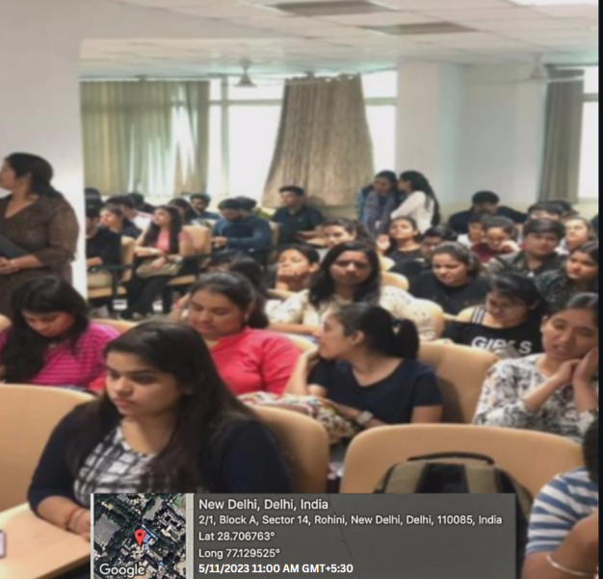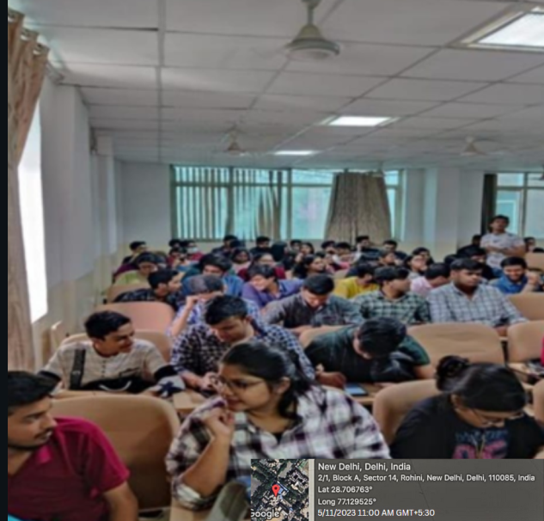

The webinar started at 11.00 am. All the faculty members and students attended the webinar. The resource person Ms. Sonal Agarwal Bali joined the webinar on time. She was welcomed by Dr. Sheetal Chadda (Cordinator – IIC). She started the session at 11.05 am. She said being a successful entrepreneur means more than starting new ventures every other day. It means the right attitude towards a business and the determination and grit to achieve success. A successful entrepreneur has a strong inner drive that helps him or her to succeed. She also talked about the Six qualities of a Startup founder that are Vision, Grit and determination, Integrity, coach ability, The ability to recruit and inspire and Unfair advantage.

Prepared and Submitted By: Prof. (Dr.) Urvesh Chaudhery

FLYER OF EVENT
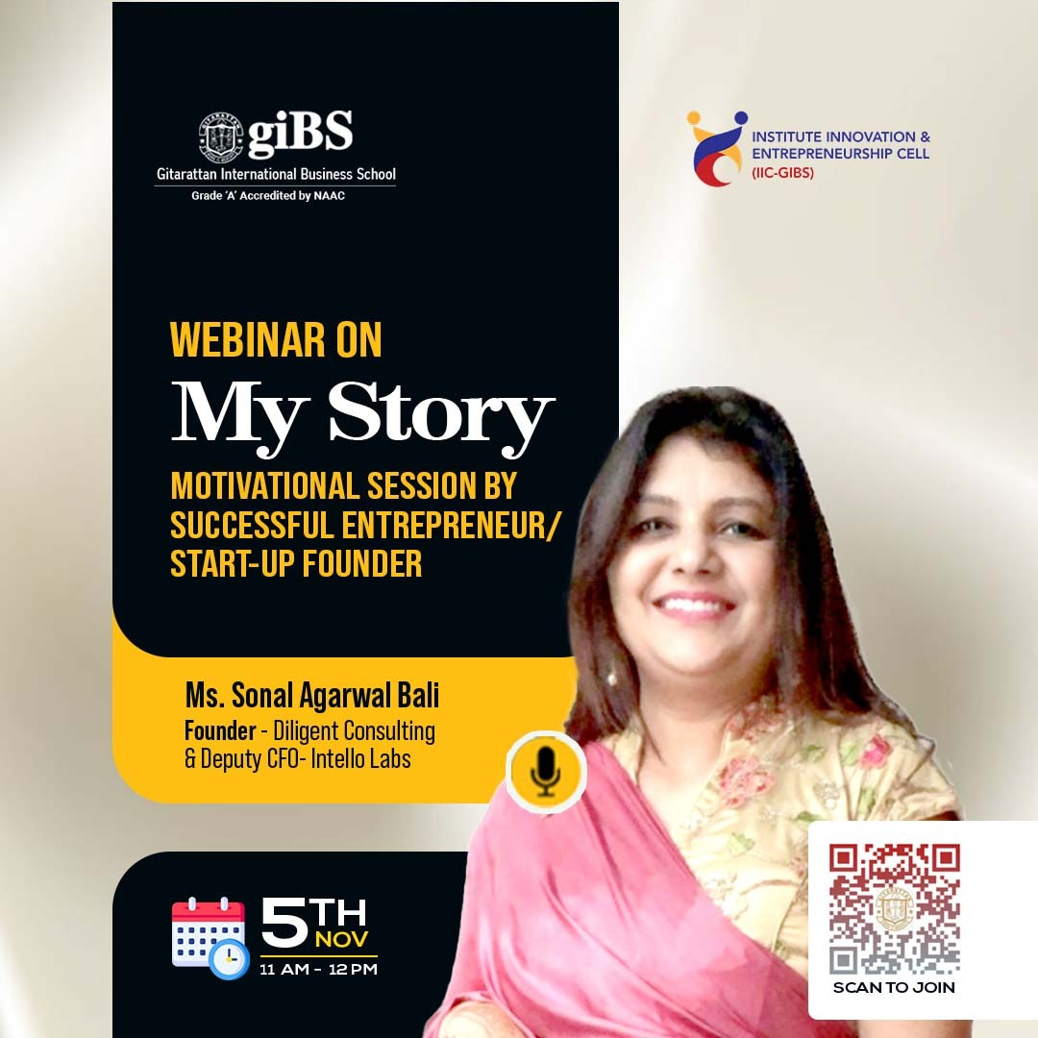
TYPE OF EVENT | Webinar
VENUE | GIBS seminar hall floor 1st
TIME & DURATION | 11.00 am – 12.00pm ( 1 hr)
CONDUCTED BY | IIC
ORGANISED FOR | All students of Management Department
NAME OF THE COORDINATOR | Prof. (Dr.) Urvesh Chaudhery
ATTENDANCE | 99
RESOURCE PERSON | Ms. Sonal Agarwal Bali  Founder, Diligent Consulting & Deputy CFO-Intello Labs
OBJECTIVES OF THE EVENT | - To promote the importance of entrepreneurship and innovation as career opportunity and inculcate skill set required for a young graduate.  - To stimulate the overall architecture of the Entrepreneurship life cycle and how student can create innovative product by undertaking relevant methods.  - To make students aware about the success story of the resource person so that students get motivated towards Entrepreneurship
LEARNING OUTCOME | - Students understood the basics of Entrepreneurship and its Importance in modern society  - They acquired skill set required to become an Entrepreneur and how to convert simple idea into an innovation.

